Your EdVenture into Robotics

You’re a Controller
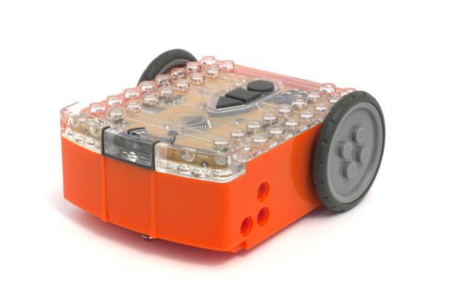

Barcode - Clap controlled driving

meetedison.com

Contents

Introduction 3
Getting started 4
EdVenture 1 – Clap controlled driving 6
EdVenture 2 – Avoid obstacles 7
EdVenture 3 – Follow torch 8
EdVenture 4 – Line tracking 9
EdVenture 5 – Bounce in borders 11
EdVenture 6 – Sumo wrestle 12
EdVenture 7 – Remote control driving 13
Calibrate obstacle detection 15
What’s next? 16

Introduction
Edison is your new robot buddy who will teach you about electronics, programing and robotics in a fun and engaging way.
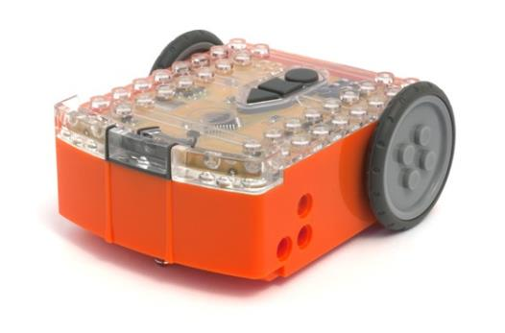
He’s equipped with all the sensors, outputs and motors needed to introduce you to the amazing world of robotics.
That’s great, but what is robotics? Well that’s not an easy question to answer. Edison’s creator, Brenton O’Brien says “a robot is a machine that can behave autonomously” . This means that a robot can think or make decisions on its own and act on those decisions. Many other people have different definitions, but we like this one as it’s nice, simple and applies to what you’re about to learn.
Edison the robot compatible with LEGO products
Robotics wouldn’t be possible without electronics, so Edison has his own electronics and you can see it all through his transparent top. There are resistors, capacitors, transistors, motors and more, but the most important electronic part is Edison’s microcontroller.
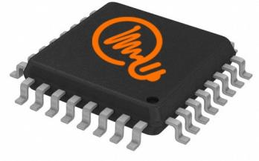
Edison’s microcontroller
The microcontroller is like Edison’s brain. It’s where all his ‘thinking’ happens. Edison’s microcontroller is very similar to the processor chip inside a computer, only much smaller. And just like a processor chip in a computer, Edison’s microcontroller has programs. The programs allow Edison to make decisions and ‘think’ for himself.

Edison comes with pre-loaded programs that are activated by driving over special barcodes. Here is a sample barcode that activates Edison’s line tracking program.
A barcode that activates Edison’s line tracking program

Getting started

Let’s get Edison ready to go!
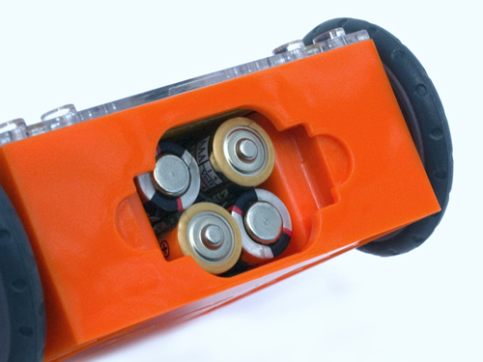
Ensure the batteries are the right way

Open the battery compartment and remove the programming cable. Now insert 4 ‘AAA’ batteries. Refer to the image to ensure that the batteries are the correct way around and clip the battery cover on.
If you haven’t already done so, stretch the tyres over the wheels.

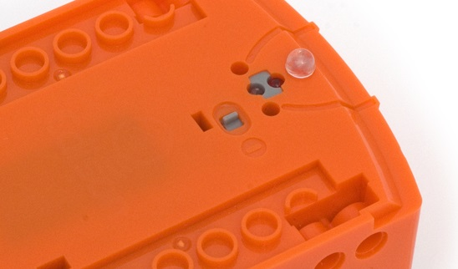
Push the switch towards the on symbol

Turn Edison on by sliding the power switch to the on position. Edison’s red LED lights will now start flashing.

Edison is ready to go!

Get to know Edison
To use Edison you’re going to need to know where all his sensors are and what his three buttons do. Have a look at the images below. You may need to come back and have another look as we go through the EdVentures.
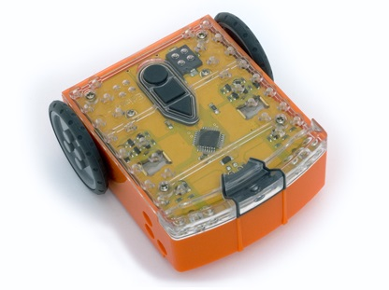
Buzzer/clap detector
Record button
Stop button
Play button
Left light sensor
Left infrared LED
Left red LED
Right light sensor
Right infrared LED
Right red LED
Get to know Edison’s sensors and buttons

Play button – Start program
Stop button – Press to stop a program
Record button – 1 press = download program, 3 presses = read barcode

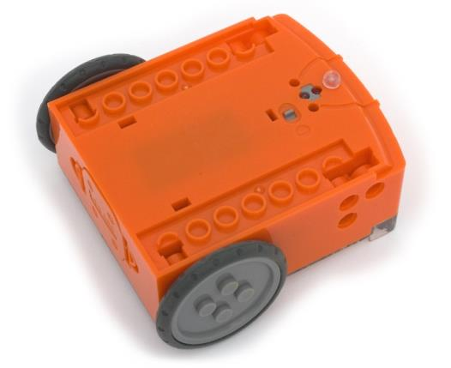
Line tracking sensor
Power switch
Edison’s power switch and line tracking sensor

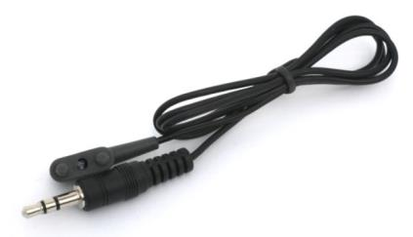
Edison’s line tracking sensor is made up of two parts a red LED light and a light sensor. The red LED shines light on the ground, if the ground is white and therefore, reflects light then the light sensor will get a high light reading. If the ground is black and therefore, does not reflect light then the light sensor gets a low light reading.
EdComm programming cable

The EdComm cable is used to download programs to Edison. It connects into the headphone socket on your computer or tablet.

EdVenture 1 – Clap controlled driving
Edison is equipped with a sound sensor and can detect loud sounds like clapping.
This barcode activates Edison’s ‘Clap controlled driving’ program. The program listens for a loud sound like a clap and Edison responds by turning to his right. If you clap twice he drives forward and stops.

Reading the barcode
1. Place Edison facing the barcode on the right side
2. Press the record (round) button 3 times
3. Edison will drive forward and scan the barcode
Barcode - Clap controlled driving

What to do
Place Edison down on a flat surface and press the play (triangle) button.
Now clap your hands close to Edison. He will turn to his right. Now clap your hands twice and Edison will drive forward about 30cm.
Also, try tapping Edison with your finger, once and then twice.

EdFact
Sound sensors just like the one in your Edison are used in modern cars to detect when the engine fires each cylinder. This information is fed to the car’s computer to ensure that the firing is occurring at just the right time. If the engine is firing too late it can cause damage to the engine. Ensuring that the firing is happening at just the right time also ensures the most economical fuel consumption.

EdVenture 2 – Avoid obstacles
Edison can see in the ‘dark’ using invisible light to detect obstacles and avoid collisions.
This barcode activates Edison’s ‘Avoid obstacles’ program. The program drives Edison forward, when an obstacle is detected he reverses and then turns on the spot away from the obstacle, then continues to drive.

Reading the barcode
1. Place Edison facing the barcode on the right side
2. Press the record (round) button 3 times
3. Edison will drive forward and scan the barcode
Barcode – Avoid obstacles

What to do
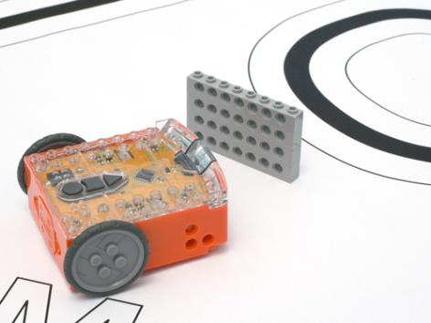
Assemble some obstacles for Edison to avoid, such as walls made from LEGO bricks. The obstacles need to be at least the same height as Edison (3.5cm/1.5in).
You could even build a maze for him to escape from.
Press the play (triangle) button and watch Edison approach an obstacle and then turn away to avoid colliding with it.

EdFact
Edison’s obstacle detection system uses the same invisible light that your remote control uses to tell the TV to change channel. This light is called ‘infrared’ or ‘IR’ and is invisible because it has a longer wavelength than the human eye can see.
Edison emits IR from two light emitting diodes (LEDs), one on the left and one on the right. In between the two LEDs is an IR sensor. The sensor detects when IR is reflected from an obstacle. If the IR is reflected from the left LED then the obstacle is on the left. If the IR is reflected from the right LED, then the obstacle is on the right.
Is Edison not behaving? Does he bump into obstacles or does he jump at shadows? Go to page 14 to see how to calibrate his obstacle detection system.

EdVenture 3 – Follow torch
Edison loves light! He will drive towards the brightest light source even if it means falling off the table. Such is love!
This barcode activates Edison’s light following program. The program uses Edison’s light sensors and motors to follow a torch (American English: flashlight).

Reading the barcode
1. Place Edison facing the barcode on the right side
2. Press the record (round) button 3 times
3. Edison will drive forward and scan the barcode
Barcode – Follow torch

What to do
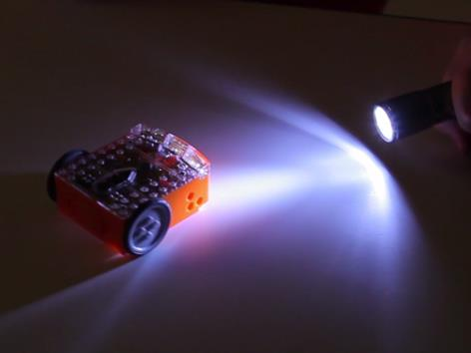
You will need a torch/flashlight and a flat surface away from any really bright light, such as sun light.
Press the play (triangle) button and aim the torch at Edison. Once he ‘sees’ the bright source of light he will drive towards it.
By moving the torch you can control where Edison drives to. Does this behaviour remind you of anything?

EdFact
This is one of Edison’s most interesting programs, because it mimics the behaviour we see in some flying insect. I’m sure you’ve seen moths on a hot summer night swarming around a bright light. This type of robotic behaviour is called ‘phototropism’ and is normally found in plants that grow towards the sun.
This program is also very interesting, because Edison is behaving autonomously. This means that he is thinking for himself and responding to changes in his environment.
Is he alive?

EdVenture 4 – Line tracking
Meet the holy grail of enthusiast robotics; line tracking. Line tracking is a very popular robotics activity as it’s fun to watch the robot go around and around a track. See how many people ask you “Is that line magnetic?”
This barcode activates Edison’s line tracking program. The program uses Edison’s line tracking sensor and motors to follow the edge of a black line.

Reading the barcode
1. Place Edison facing the barcode on the right side
2. Press the record (round) button 3 times
3. Edison will drive forward and scan the barcode
Barcode – Line tracking

What to do
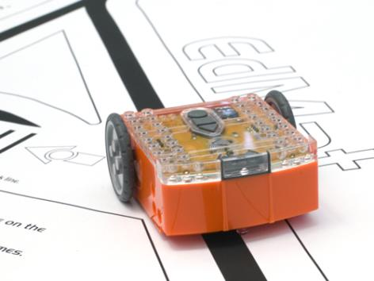
The first thing you need is a line. You can print the small track on the next page, print the large A1 (84cm x 59cm) EdMat from meetedison.com/downloads or make your own using black electrical tape on a white table (the line must be 1.5cm/0.6in thick).
Place Edison to one side of your line, so that the line tracking sensor is on white. Now press the play (triangle) button and watch Edison follow the line.

EdFact
Edison’s line tracking sensor shines light on the surface and then measures the amount of light that is reflected back. White reflects a lot of light, giving a high light reading and black reflects very little, giving a low light reading.
To track the line Edison is in a constant state of dissatisfaction. When he is off the line, he turns right to get on the line. But when he’s on the line, he turns left to get off the line. This results in him waddling on the edge of the line.

EdVenture 5 – Bounce in borders
Ever heard of Dromophobia? Well, it’s a fear of crossing the street and we’re going to give a version of it to Edison! Cue evil laugh…Muwhahaha!!!
This barcode activates Edison’s bounce in borders program. The program uses Edison’s line tracking sensor and motors to stop him from crossing a black line.

Reading the barcode
1. Place Edison facing the barcode on the right side
2. Press the record (round) button 3 times
3. Edison will drive forward and scan the barcode
Barcode – Bounce in borders

What to do
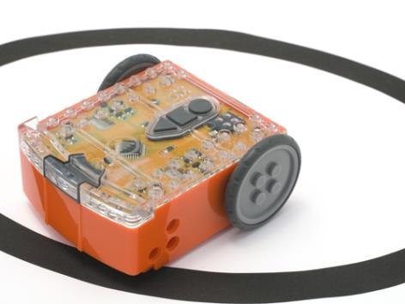
You can use the oval track on the previous page, or use the large A1 (84cm x 59cm) EdMat from meetedison.com/downloads or create your own (the line must be 1.5cm/0.6in thick).
Place Edison inside the borders and press play (triangle) button.
Edison will drive forward until the line tracking sensor detects the line, then reverse back, turn and continue driving.

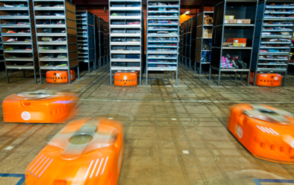
EdFact
Line tracking and bounce in borders are fun programs, but there’s a serious side. Warehouses that use robots to move items around, use lines or markers on the ground to guide the robots to their destination. These robots use barcode markings on the floor to navigate in Amazon’s warehouse.

EdVenture 6 – Sumo wrestle
Bring on the robot wars!
This barcode activates Edison’s Sumo wrestle program. The program brings together bounce in borders to stay with in the ring and obstacle detection to hunt and find the opponent.

Reading the barcode
1. Place Edison facing the barcode on the right side
2. Press the record (round) button 3 times
3. Edison will drive forward and scan the barcode
Barcode – Sumo wrestle

What to do
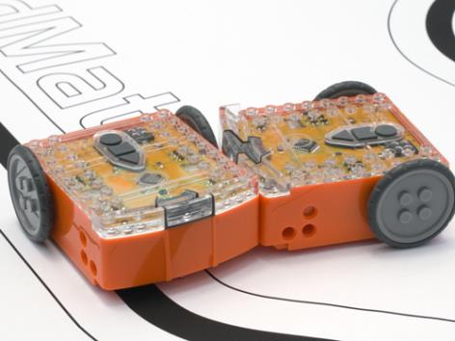
Create your own sumo wrestle ring using black electrical tape on a white surface. The ring should be around 40cm/16in in diameter.
Place two Edisons inside the ring and press play on both at the same time.
Each Edison is now slowly driving forward, staying inside the ring and ‘looking’ for the opponent. If the opponent is detected Edison charges forward at full speed until the edge of the ring is detected. He then reverse back victorious and continues to look for another opponent.
Battles don’t always go to plan, as there are so many variables, such as the angle of the opponent, the proximity of the edge of the ring or just plain bad luck.

EdVenture 7 – Remote control driving
So you really want to control your Edison!? Here’s your chance and you can do it with your TV remote control.
These barcodes allow Edison to learn the commands from your TV or DVD remote control.

Reading the barcode
1. Place Edison facing the barcode on the right side
2. Press the record (round) button 3 times
3. Edison will drive forward and scan the barcode
4. Press a button on your TV/DVD remote that you want to activate that function

Barcode – IR learn drive forward

Barcode – IR learn drive backward

Barcode – IR learn spin right

Barcode – IR learn spin left

Barcode – IR learn turn right

Barcode – IR learn turn left

Barcode – IR learn play beep

Barcode – IR learn play tune

What to do
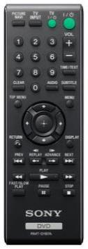
Teach Edison each barcode one by one. Use buttons on your remote control that align with the action Edison will perform, such as use the up arrow (volume up) for drive forward etc. You can make changes whenever you want so play around with which buttons suit you the best.
Now go driving!
Edison is compatible with around 75% of TV and DVD remote controls. If one of your remotes doesn’t happen to work try another one. If none of your remotes work then you can purchase an inexpensive ‘universal remote’ and set it to be a Sony DVD remote control.

Calibrate obstacle detection
You can control the sensitivity of Edison’s obstacle detection system. By making it more sensitive he can detect obstacles further away, and by making it less sensitive he will only detect very close obstacles.

Reading the barcode
1. Place Edison facing the barcode on the right side
2. Press the record (round) button 3 times
3. Edison will drive forward and scan the barcode
Barcode – Calibrate obstacle detection

Set maximum sensitivity
First scan the above barcode, then press the play (triangle) button. Edison is now in calibration mode. Remove any obstacles in front of Edison.
The left sensitivity is calibrated first.
1. Repeatedly press the play button (this increses sensitivity) until the left red LED is flickering.
2. Repeatedly press the record (round) button (this decreases the sensitivity) until the LED completely stops flickering.
3. Press the stop (square) button to calibrate the right side.
4. Repeatedly press the play button until the right red LED is flickering. Now repeatedly press the record button until the LED completely stops flickering.
5. Press the stop button and the calibration is complete.

Custom sensitivity
You can set the distance that obstacles are detected by placing an obstacle in front of Edison and repeating steps 1 through 5.

What’s next?
Now that you’ve learned all about Edison’s abilities, sensors and controls you can move on to programming him. Go to www.meetedison.com and look for EdBook 2 ‘Your EdVenture into Robotics – You’re a programmer’. In this EdBook you’ll learn how to write your own programs to get Edison to do exactly what you want!
The programs are written using free software called EdWare. You build programs using drag and drop icons. Here’s what a simple line tracking program looks like.
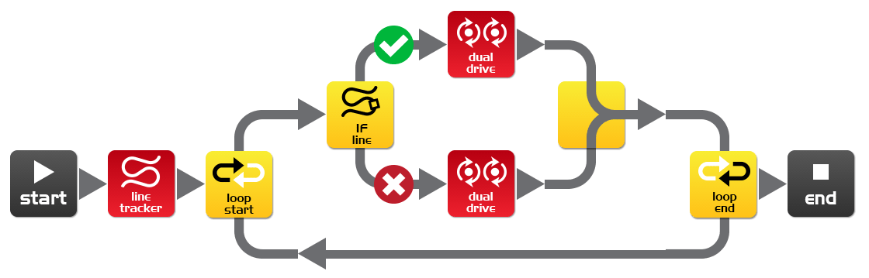
Don’t forget that you can download the free EdMat activity mat in colour or black and white. The EdMat is A1 size (59cm x 84cm) and can be printed at your local print shop for a small fee. Download from: meetedison.com/downloads

